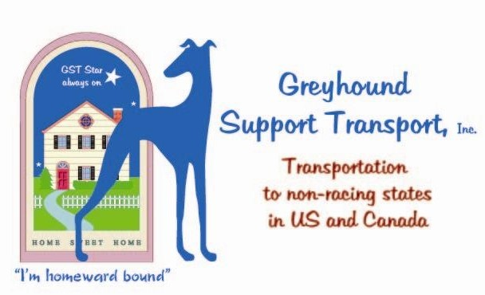

4766 Cole Street West Palm Beach, FL 33417
(305) 753-1985
EIN: 94-3458947
greyhoundsupporttransport@gmail.com

GREYHOUND ADOPTION APPLICATION
This application is designed to help you think about the living requirements of retired greyhounds and decide if adoption is right for you. It may seem like a lot of questions, but please take your time and carefully consider your answers. We take our responsibility to the dogs and future owners very
seriously. We hope this application assists you in choosing your Greyhound as much as it helps us guide you to the right dog.

Personal and Contact information

Name: Date:

Email address:

Address, City, State, Zip:

Do you . Own . Rent . Other:

If you do not own, provide Landlord name: & phone:

Home Phone: Cell Phone: Work Phone:

If you don’t own your home, do you have permission to have a large pet?

How did you hear about our adoption and support services?

Were you referred by or know a GST volunteer that you’d like to use as a reference?

Names of all household members and their ages:

Please describe the other pets in your home or any who visit frequently:

Why would you like to adopt a greyhound?

If you aren’t adopting right away, please explain when you anticipate doing so and the reason for the delay so that we can help you plan accordingly:

Who would be the primary caregiver of your greyhound?

Have you ever owned a greyhound or volunteered with an adoption group in the past?

Please tell us about your other greyhound(s):

Are all members of your household aware of and in agreement with adopting a greyhound?

Are any members of your family actively serving in the Military?

Do you expect any deployments or reassignments in your future?

If so, please explain how you would make it possible for your greyhound to remain a part of your family:

THE NEEDS OF YOUR RETIRED ATHLETE

Greyhounds are a breed with a life expectancy of 10 years or more. Are you prepared for a commitment to a dog for the remainder of its life?

Do you have the financial resources to meet the medical needs of a large dog, including good quality food, heartworm preventative, vet care, and flea medications, as needed?

Greyhounds are sighthounds, which means their eyesight is highly developed. They are also friendly and curious, as well as filled with the desire to run whenever given the chance. A greyhound, therefore, can never be trusted off-leash unless in a secure, fenced area. A loose greyhound is usually a dead greyhound. Do you understand this requirement and agree to keep your dog safe by always leashing it unless in a securely fenced area?

If you have young children, have you considered how you will prevent them (and their young friends) from accidentally opening doors and/or gates that would allow your greyhound to escape?

Tell us what provisions you have, or intend to make, to keep everyone safe.

Heartworm is very deadly and common in this part of the country. Are you willing to keep your greyhound on preventative all year, as recommended by your veterinarian?

Greyhounds are not a breed suited to living outside. For many reasons, a retired greyhound needs (and wants) to live inside with its new family. They certainly enjoy time outside, but long periods alone, unsupervised, invite a whole host of problems.

Do you understand this requirement and agree that your greyhound will be an inside member of your family?

Greyhounds fresh from the track sometimes feel the need for the security of a training crate. We advocate the use of these crates when it appears the greyhound needs it, in order to learn the rules of home life and remain safe when unsupervised. Remaining comfortable with being in a crate is also helpful in the case of vet trips, boarding kennels, illness or injury, etc. Are you willing to buy and learn to use a crate to help your dog adjust if it seems to be required?

YOUR LIFE TOGETHER

Please list a Veterinarian that we may contact as a reference:

Clinic Name: Vet Name:

Phone: Address:

City, State, Zip:

Length of time you've used this vet:

OR

We don't have a vet reference because:

Representatives from GST may plan an informal “Home Visit”, prior to
placement of the greyhound, to help you evaluate possible dangers or concerns for your hound. These visits are always arranged at your convenience and take place once your application is approved and your Greyhound has been chosen in order to deliver your hound and to make sure that all parties are comfortable.

Are you willing to allow a representative of our organization to plan an informal Welcome Visit in your home prior to placement of the greyhound?

How long will your greyhound usually be expected to remain alone each day?

How does your job affect the time spent away from home?

How will you provide your greyhound with 'potty breaks' and exercise?

. Access to a fenced area. What kind/how big?

. We will walk on a leash

. Other. Please describe:

Please share any activities or hobbies you enjoy, in which you hope to include your greyhound:

Does your home have any situations with which your greyhound will have to become comfortable, such as members with acute illnesses, allergies or physical limitations, very young active children, etc? If yes, please describe:

YOUR GREYHOUND

Have you already met or become interested in any of our dogs specifically?

If yes, please list name:

Please list any preferences as to age, color, or gender:

If you have any preferences as to age, color, or gender, please explain why these considerations would be important enough to guide your possible choices:

Often, special-needs (medical conditions, age, shyness, or past injuries) dogs are the hardest to place and we always wish to offer a chance for owners to consider giving them a forever home. Understanding that the final decision would always be yours (and will NOT affect your ability to adopt from GST), would you be willing to consider adopting a
greyhound that has special needs? . yes . no

If yes, which type would you consider:

GST highly recommends reading/research before adoption, including “Greyhounds for
Dummies” and “Childproofing Your Dog”. Have you read any books or conducted any research to prepare for adopting your greyhound?

Describe the personality of your absolute perfect greyhound:

Is there a personality trait or habit that you simply CANNOT accept in a dog?

What sort of expectations do you have in the way a greyhound will impact your life, family and home?

Do you have any other concerns you would like us to address?

Please tell us if there is anything else about your home, family, lifestyle, or adoption needs that you'd like us to know:

THE LEGAL PART (Please read carefully!)

In submitting this application, I am authorizing GST to investigate
any answers given on this form. I understand that in the interest of making the best placements possible, they have the right to deny any application or ask for additional information but will NOT use this information for any other purpose in order to protect my privacy. I understand that this document will become a permanent part of my adoption application record for GST.

Signature & Date Printed Name

GST would like to thank you for considering the adoption of a
retired racing greyhound. Please call or email to greyhoundsupporttransport@gmail.com with any questions you may have while preparing this form.

Please mail printed applications to:

Greyhound Support Transport
4766 Cole Street, West Palm Beach, FL 33417-5947

- OR-

E-mail completed applications to: greyhoundsupporttransport@gmail.com

